Final Mock Test

Question1

(a) State the procedure of introducing the vector potential  and scalar potential in the time-varying electromagnetic fields; Write their expressions;

(b) Explain the Coulomb's gauge and Lorentz’s gauge; which one will be used in time varying field and explain the reason?

(c) The interface between air （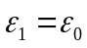）and dielectric medium（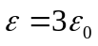） is x=0 plane, the electric field on the interface of air side is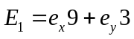, then what is the electric field on the interface of the dielectric medium?

(d) Explain the polarization mode of the following uniform plane wave;

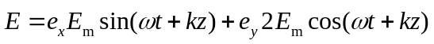

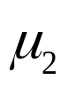
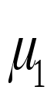
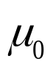
Question2 The radius of the inner conductor of a coaxial line is a, the interior radius of the outer conductor is b, the thickness of the outer conductor is neglected. Medium with permeability of 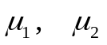 is filled between the two conductors, which carrying a direct current I.
a
b
Find: (a) the magnetic field intensity H for every region;
(b) the energy of the magnetic field per unit length;
(c) the inductance per unit length

Question3 The complex expression magnetic field intensity of plane wave in air is 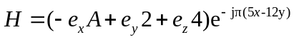, Where A is constant . Find :
(a) ；
(b) wavelength and frequency；
(c) the value of A；
(d) The complex expression electric field；
(e) average Poynting vector .

Question4
The electric field of incidence wave is 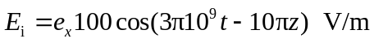 , it is vertically incident to the interface at z = 0 from the region (z < 0) of air to the region (z > 0) of a perfect dielectric (μ_{r}=1 ε_{r} = 4) . Find :
(a) the wavelength, phase constant and wave impedance in z > 0；
(b) the total complex expression of electric and magnetic fields in the region in z < 0；
(c) the total complex expression of electric and magnetic fields in the region in z > 0；
(d) how to reduce the standing wave ration on the interface?

